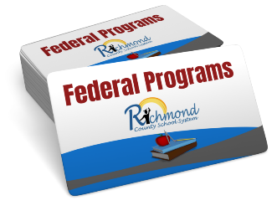

**Lucy C. Laney High School**

**1339 Laney Walker BLVD.**

**706-823-6900**

**Dr. Cordaryl C. Middleton**

**Title I Annual Meeting**

**Wednesday, October 1, 2025**

**5:30 PM to 6:30 PM**

**Location: Laney High School Media Center**

**ATTENTION: ALL PARENTS**

**Please make plans to attend and participate in this very important meeting as we discuss and revisit the many aspects of Title I Parent Engagement for the 2025-2026 School year. Your presence and participation will be greatly appreciated.**

***Topics of discussion will be as follows:***

**Title I Program Parents Right to Know**

**School-Parent Compact Parent and Family Engagement Policy**

**Budget/Funding Building Capacity**

**Assessments Curriculum**

**Volunteer Opportunities School Goals**

**School Improvement**

**Parents, we need you! You do not want to miss this opportunity to learn about and participate in the Title I Parent and Family Engagement program at your school!**

**For more information, contact the school office or your parent facilitator/designee:**

**Colleen Fisher**

**706-826-1276**